**CS 490/5590 Python/Deep Learning Lab 1 Report**

Team member: Syed M Rahman

Team member: Kenton Hanifl

**Introduction:**

We wrote 6 programs that handles various aspects on the basics of Python programs like class, web scraping, loop structures, conditional statements, strings, lists, tuples, functions. Python is an object-oriented programming language. It is interpretive.

**Project Description:**

The first program computes the net amount of a bank account based on the transaction log from the console input. It asks the user to either choose a deposit or withdrawal option and then the amount for that transaction. Then depending on the type of transactions & amount the user entered, it provides a net bank amount.

The second program takes a list of tuples and then creates a dictionary with the names as the key and the subject & scores in sorted order

The third program takes a list of student names for 2 courses from the console input. Then it prints the lists of students who are in both classes and the list of students who are just in course but not the other.

The fourth program takes a string and then finds the longest substring without repeating characters

The fifth program is an Airline Booking Reservation system that implements classes, instances of classes, inheritance etc.

The sixth program parses a web page and downloads designated information from the web page and puts that info into a file

**Methods:**

We used a Python IDE environment to create the programs. We used a program called PyCharm.

Program 1: The While loop and the IF IF Else conditional statements were used

Program 2: The dict(), append(), update(), sort() and for loop was implanted

Program 3: The set() was used to create 2 sets of student names. The & and ^ Boolean operations were used to find the students who are in both classes and the students who are just in one class but not the other

Program 4: A function was created in this program. A for loop was used to find if a character existed in a substring and then using the if else conditional statements and the len() method to compare the two sub-strings to find the longest substring without any repeating characters.

Program 5: For this program, we used classes, instances of classes and inheritance to implement the Airline Reservation system

Program 6: This program scrapes a wiki web page using Beautiful Soup library and then saves the capitals and states of USA in a file

**Datasets:**

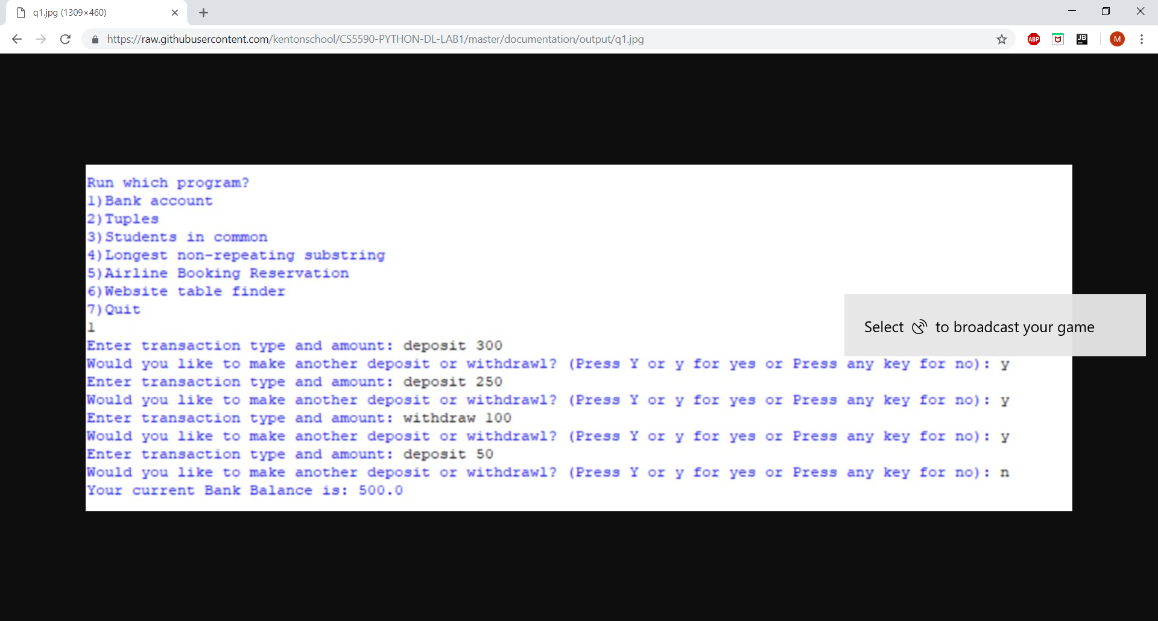

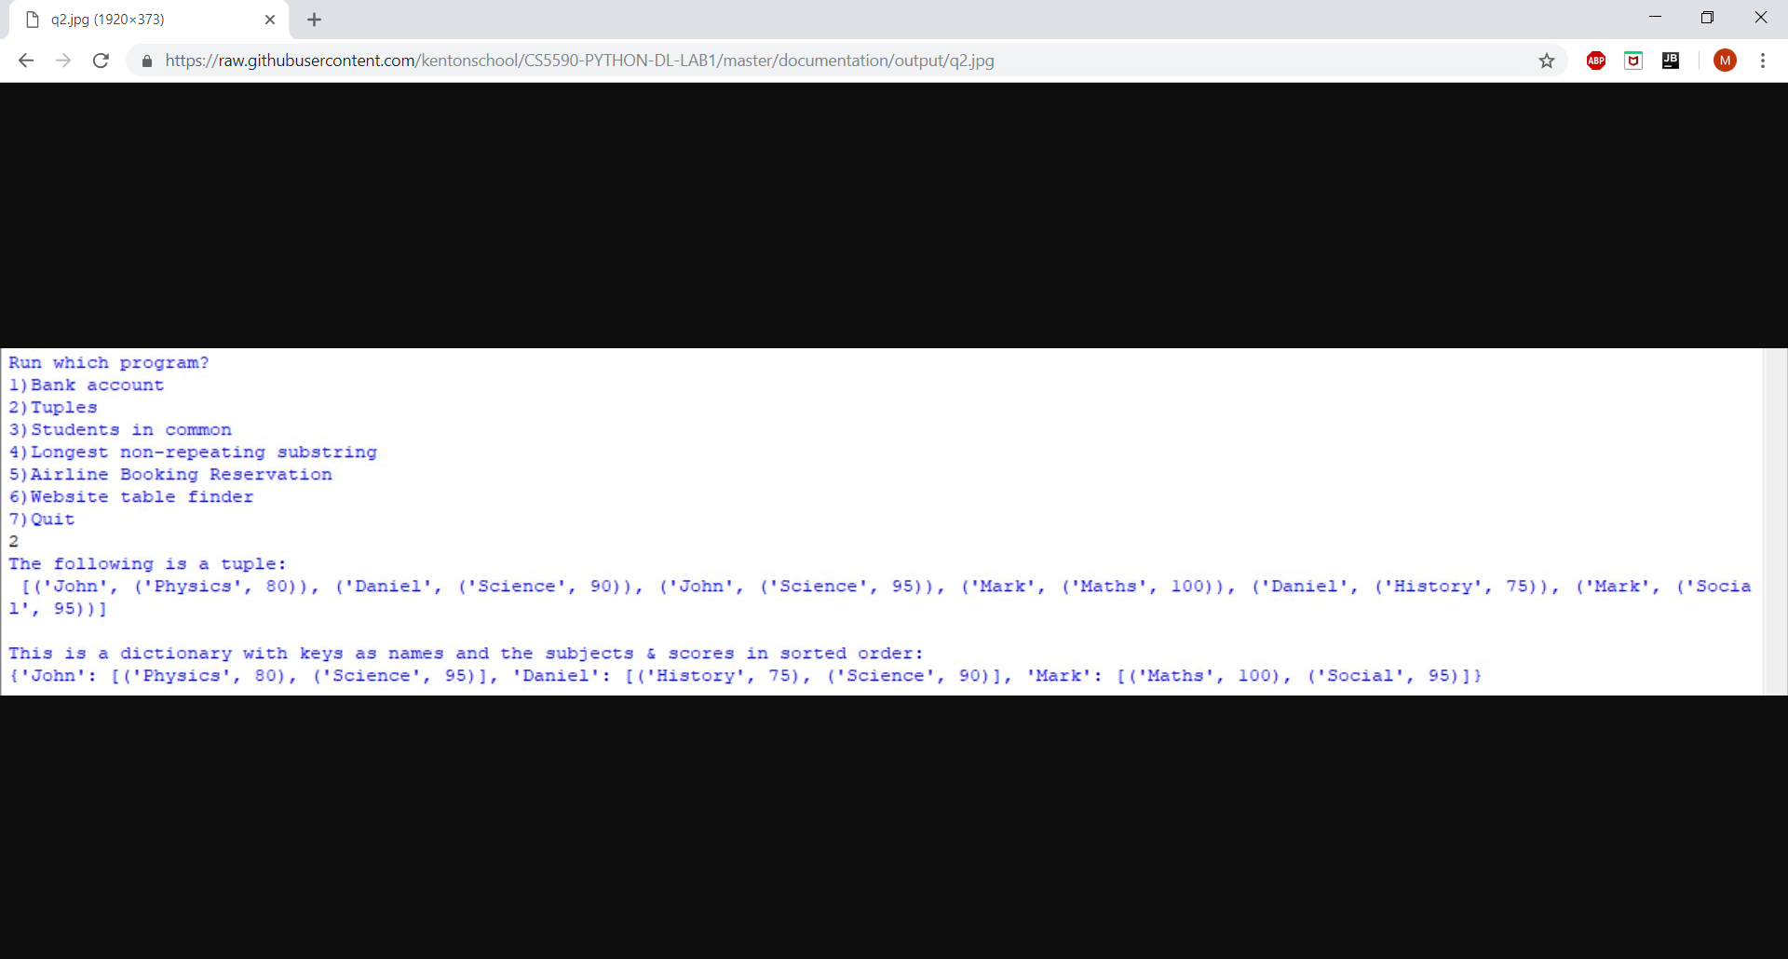

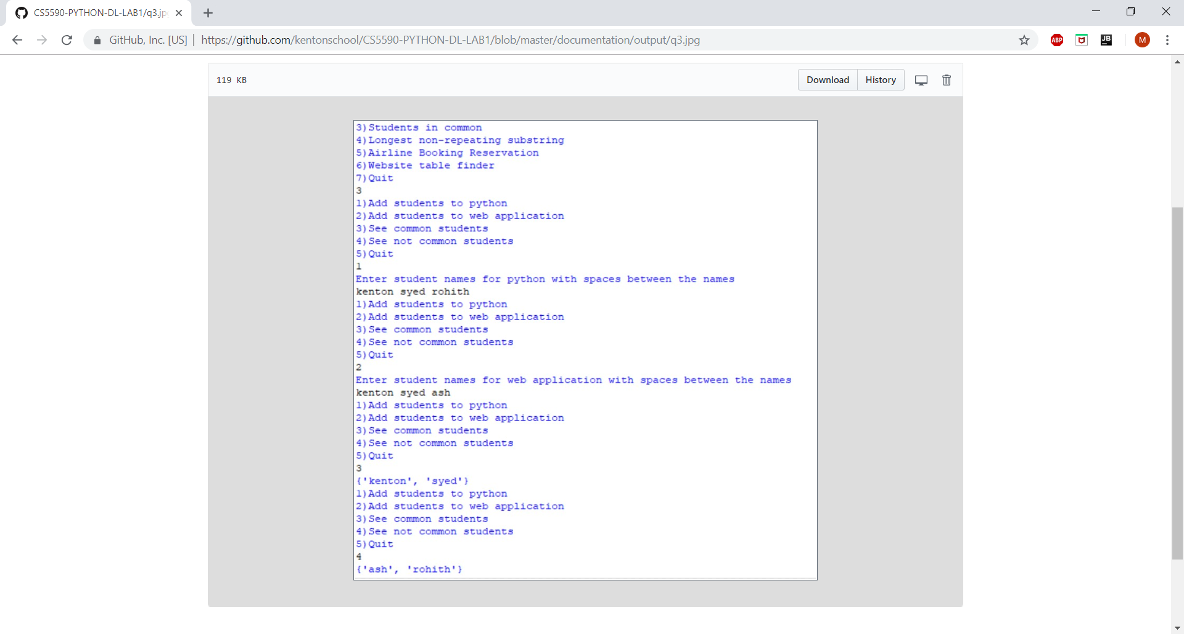

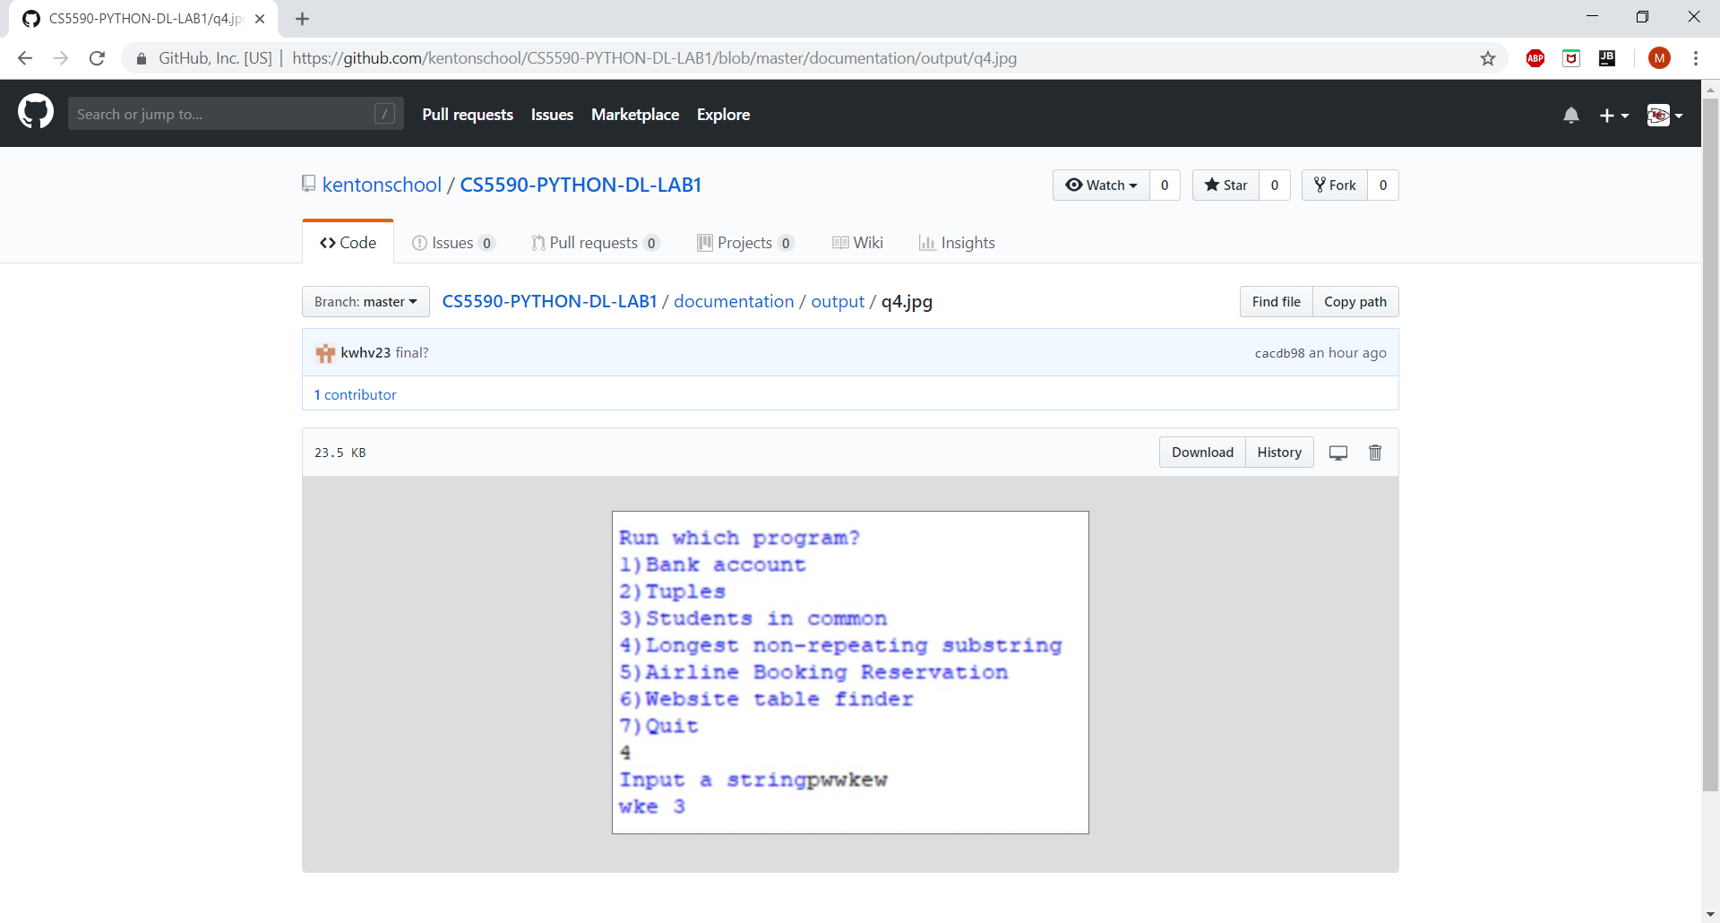

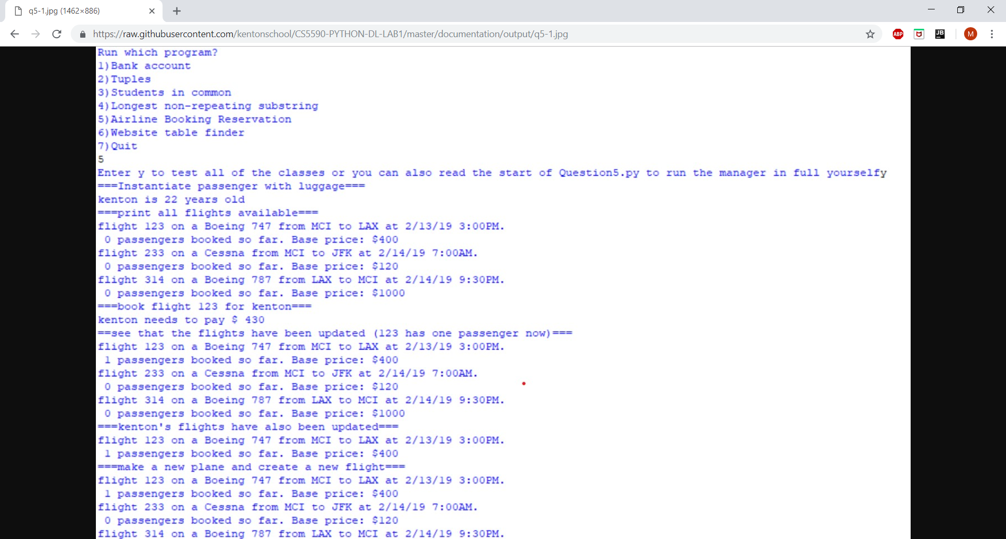

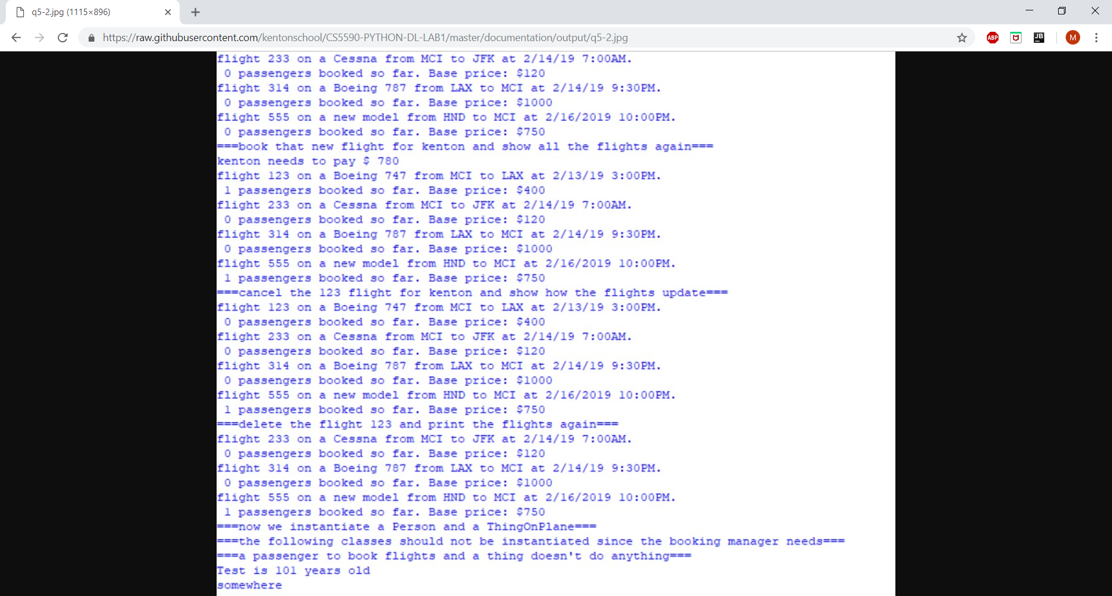

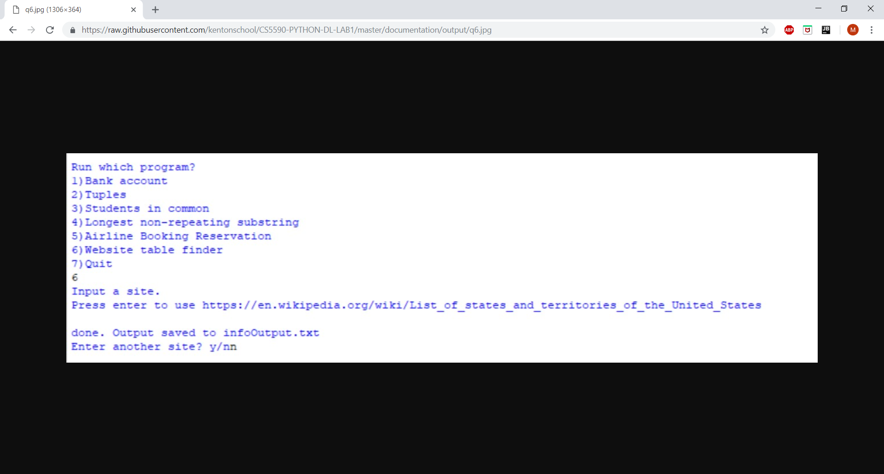

**Evaluation:**

Our internal tests show these programs are running correctly

**Conclusion:**

This was the first team Lab project implementing Python. This was a good learning experience and team work.